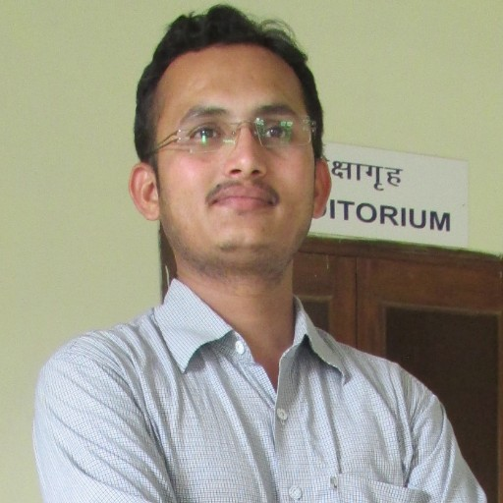
SAMEER S. SHAIKH
Mobile: 7841987016
Passport No : S5126798
Email: sameershaikh548@gmail.com

Objective

- To reach the highest echelons in an organization with hard work, dedication and constant endeavor to perform better and give positive results.

Profile

- Having experience from TCG life science as lab. Assistance, safety supervisor position in Pune.
- Having working experience from Saint-Gobain, Chakan as chemist & safety officer in ETP / STP / WTP PLANT.
- Making positive changes in the workplace, with respect to ensure safety standards & its measures.
- Conduct safety audits, near miss investigation, accident investigation, property damage and personal injury investigation on a plan basis.
- Having experience in construction safety with Shapoorji Pallanji.
- Currently, associated with Asian Paints in Safety department at Khandala plant.

Achievements

- Best implementation of safety procedures in work places as per safety standards.
- Maintain zero reportable accidents, zero notifiable diseases & zero dangerous occurrences.
- Achieved Rolling trophy in “Safety procedure & implementation” at Asian Paints.
- Achieved “Best safety implementation” in work places by BSC.

Projects works

- Environmental pollution and its control.
- Analysis of instrument safety and its industrial use.
- Chemical industries, environment control & Human behavior.

Work Experience

Company: ASIAN PAINTS Khandala. (ARMS India Pvt. Ltd.)
Designation: Safety Site In charge Officer
Department: Environment & Health Safety. From: Oct. 2017 till date
- Conducting safety induction for new joiner.
- Making of accident / incident CAPA.
- Conduct SUSA Procedure for workers/staff on basis of BBS safety standards.
- Prepared checklist for different tools, machines, PPEs, Lifting tools etc.
- Raise permit for routine & non-routine work in company premises.
- Inspect work places, activities then issue the work permit. As well as closing it.
- Report the U/A, U/C, N/M to manager level.
- Prepared JSA, WMS for work procedure carried out in company premises.
- Accident / Incident Investigation & its Analysis.
- Monitored Critical Activities on site & corrected the unsafe practices followed by the workers.
- Conducted Fire Mock Drill and trained the workers for the ‘Emergency Evacuation Procedure’ after hearing the emergency siren & conducted head counting of the workers Assembled at the assembly point area.
- Implementing strictly work permit system and selection & approval of PPE’s.
- Conducting Site Safety Meeting for better work environment.

Company: Shapoorji Pallanji.
Designation: Safety supervisor
From: Feb. 2016 to Oct. 2017
- Conducting Toolbox Talk (TBT) / Safety Training Programs.
- Conducting Safety Audits and Inspections.
- Maintaining Lockout & Tag out systems (LOTO)
- Arranged for marking of shutdown Assembly Point Area, Smoking, Shelter & displaying Safety slogans,
banner at the conspicuous locations.
- Ensured availability of firefighting Extinguishers where ever necessary & also trained worker for the
correct use of the same.
- Prepared Near Miss Incident statistics & maintained the records of the First aid Injuries.
- Job safety analysis, Accident investigation
- Initiating new project based on customer, process requirements and take appropriate approval from seniors.
- Explanation to Top management on weekly & monthly basis about the status of Safety points.
- Implementation of note chart to visitors to follow the safety rules, and follow it.
- Implementation of project only after proven experiments & explanation and discussion with senior.
- Conduct safety training & awareness program on safety & Health.
- Conduct safety week program.
- Introduction with visitors & customer on safety policy & rules of the organization.

Company: Saint Gobain India Pvt. Ltd. Chakan.
Designation: ETP/STP/WTP/DM/SOFTNER PLANT Supervisor (EHS)
From: Jan-14 to 30th June 2015
- Making positive changes in the workplace, with respect to ensure safety.
- Reducing number of injuries recorded, near missed records, worked as part of a close-knit team.
- Conduct qualitative risk assessments for job tasks using a pre-defined methodology and format
- Assist in controlling hazardous working conditions and unsafe employee activities.
- Ensure that each project site conforms to all applicable safety regulations.
- Document all accidents, safety violations, unsafe conditions/activities.
- Provide solutions when sites are found to be in violation of safety standards.
- Maintain all safety documents for each project site.
- Assist in preparing written appeals for safety violation citations.
- Monitoring reading & output of ETP / STP plant.
- Monitoring Consent tracker.

Company: TCG life science Ltd. Hinjawadi, Pune.
Designation: Lab. supervisor.
From: 9th May 2010 to 21st Dec 2013.
- Maintained and performed weekly inspections of equipment and office spaces and identified the need for routine maintenance. Ordered charts and equipment for proper maintenance and established regular testing schedules.
- Responded to employee injuries and administered first aid as needed for evacuations, cuts and bleeding, and injuries.
- Performed daily walk-through for safety inspection of the facilities including fire systems. Documents and photographed findings and compiled and presented statistical data on safety activities to EH&S Director. Co-ordinate the installation of fire extinguishers where necessary.
- Maintained Materials Safety Data Sheet (MSDS) on chemical used in the workplace.
- Conducting safety programs its better the way to make employee as a positive mind on safety.

Skills

- Planning and control of safety assurance measures.
- Safety audits and implementation of inspection plan.
- Excellent communication with Internal and External Customers.
- Ability to work independently.
- Capable to learn and apply new technologies.
- Familiars with various processes involved in safety management.
- Ability to interface effectively with all levels of organization.
- Team building and leader-ship qualities.
- Demonstrate strong Interpersonal and presentation skills.
- First Aid - Certified Course completed with Red Tape organization.
- Excellent presentation, oral & written communication skills.
- Ability to motive and inspire a team to achieve set goals.
- Positive attitude toward work, System focused.
- Enjoy working effectively in team to meet organization and customer requirements.
- Flexible working in any conditions, keen to learn and implement new methods

Area of interest

- OHSAS, HIRA.
- Implementing & standardizing practices as per NEBOSH.

Hobbies

1) Playing cricket.
2) Books reading.
3) Cooking.

IT Forte

- Well versed with MS-Office, Excel, Power point, Project and Internet Applications.

QUALIFICATION

Advanced Diploma in Industrial Safety
Institution and Board: M.S.B.T.E
Result: 60%, 1st class.
Year of Passing: 2014

B.sc:- (Chem.)
Institution: Sholapur University, Sholapur.
Result: 55%, 2nd class.
Year of Passing: March, 2009

Higher Secondary School Certificate
Result: 70.50%, 1st class
Year of Passing: February 2007.

Personal Details
Full Name : | Sameer S Shaikh
 | Gulam Ali Nagar, lane no.3, Mohammadwadi road, Near Limra Eng, School, Hadapsar, Pune-28.
Contact No. : | 7841987016/7841988016
Date of Birth : | 1st,July 1987
Nationality : | Indian
Marital Status : | Married
Language : | English, Hindi, Marathi
Email ID : | sameershaikh548@gmail.com.
Personal Details

I hereby declare that all the above mentioned details are true to the best of my knowledge and belief & I am confidence of my ability to demonstrate the full value of my services to you just as soon as you give me a chance to do so.
Yours Faithfully
(Sameer S. Shaikh)
Date: - Jan 2019

